**INTERNSHIP STUDIO PROJECT**

**COURSE:** **AWS(Amazon Web Services)**

**Problem Title :** **Deploy a Cloud**

*Submitted by:-*

**Anannya Priyadarshini Neog**

**Problem Statement:**

A Cloud developer is someone with multiple horizons of skills and ideas, be it Devops, Debugging or programming . You work at a software company IS Robotics , you work as a software engineer, you need to deploy ROS (Robot Operating System) on Cloud which will allow the devlopers to run their robotic simulation and do more implementation

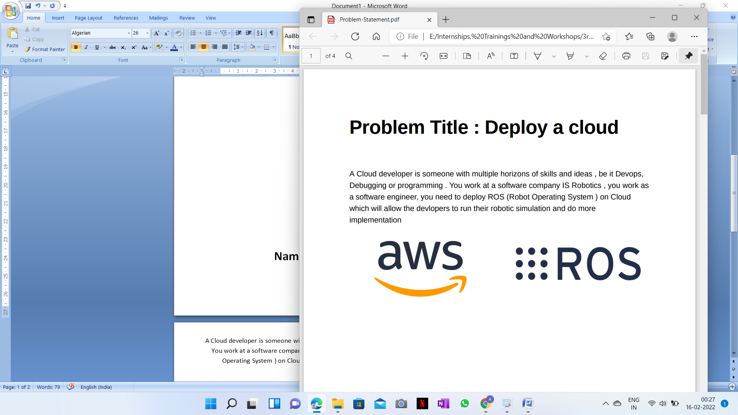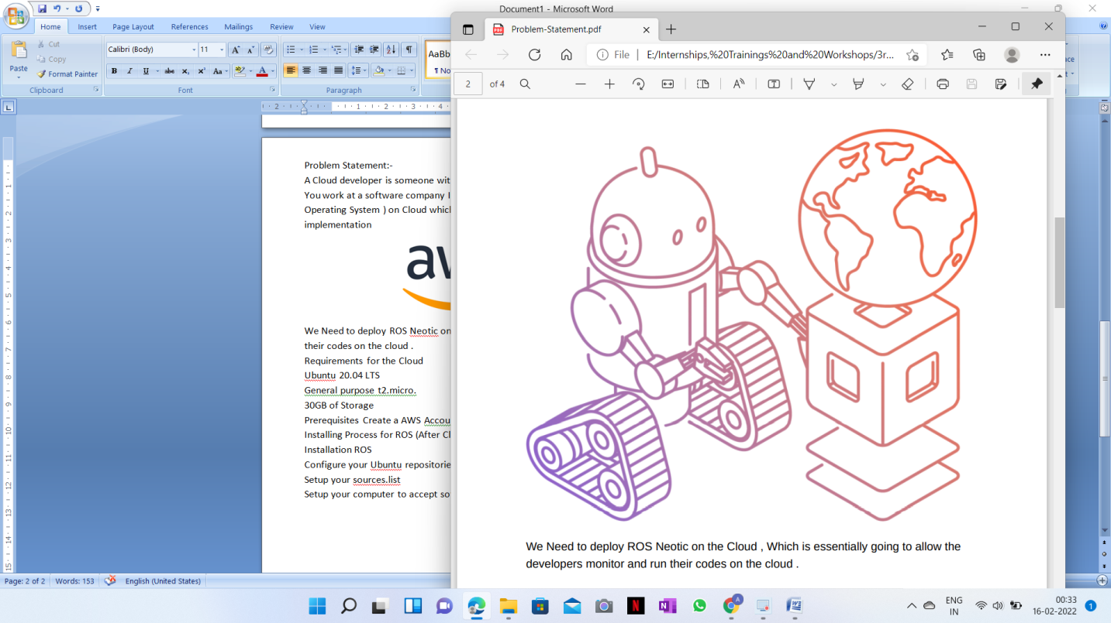

We Need to deploy ROS Neotic on the Cloud, Which is essentially going to allow the developers monitor and run their codes on the cloud.

**Requirements to make an instance for EC2 in the AWS**

* Ubuntu 20.04 LTS
* General purpose t2.micro.
* 30GB of Storage
* Prerequisites: Create a AWS Account.

**Steps to make an Instance for EC2 in AWS:**

1. **Go to EC2**

Type ‘**EC2**’ in the search bar and click the ‘**EC2 virtual server**’ after signing in

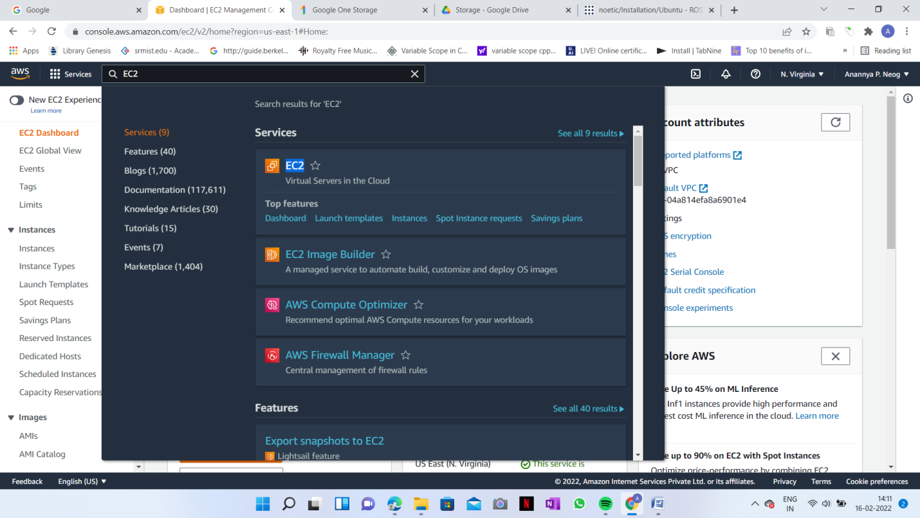

1. **Click ‘Instances’**

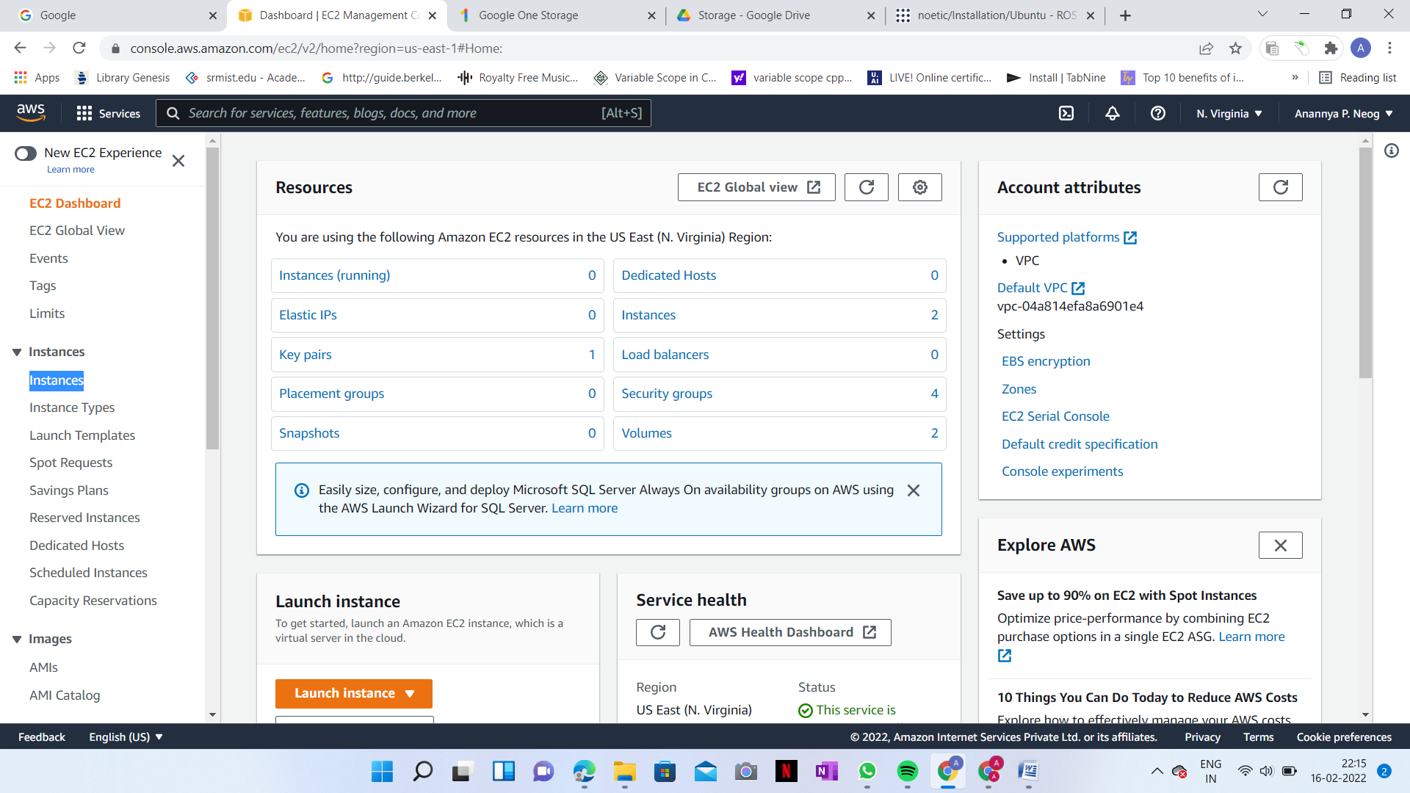

1. **Click ‘Launch Instance’**

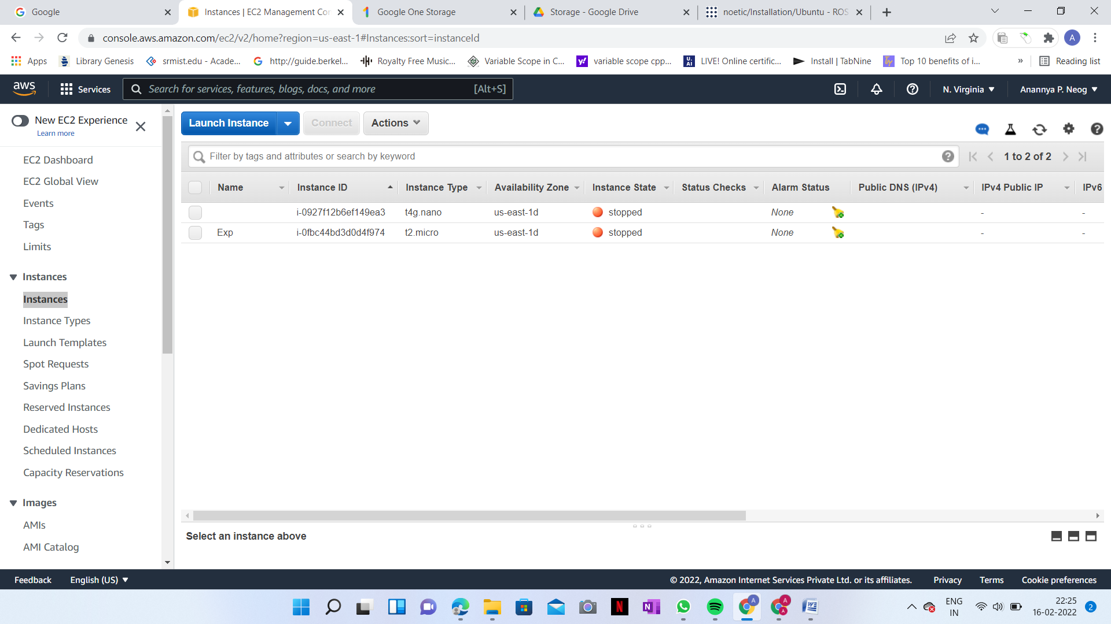

1. **Choose any machine**

We can select any machine by scrolling down but in this project I have chosen ‘**Ubuntu Server 20.04 LTS (HVM), SSD Volume Type**’ with ‘**64-bit (x86)**’ processor.

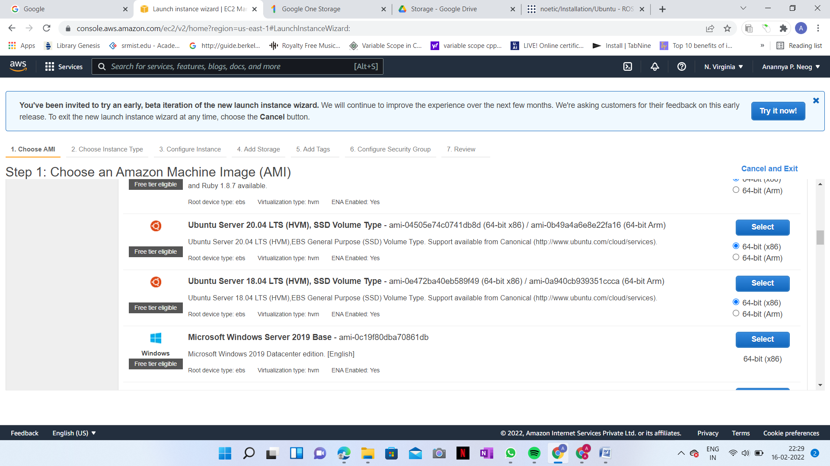

1. **Select any instance type**

Select ‘**t2.micro(Free Tier Eligible)**’ and click ‘**Next: Configure Instance Details**’

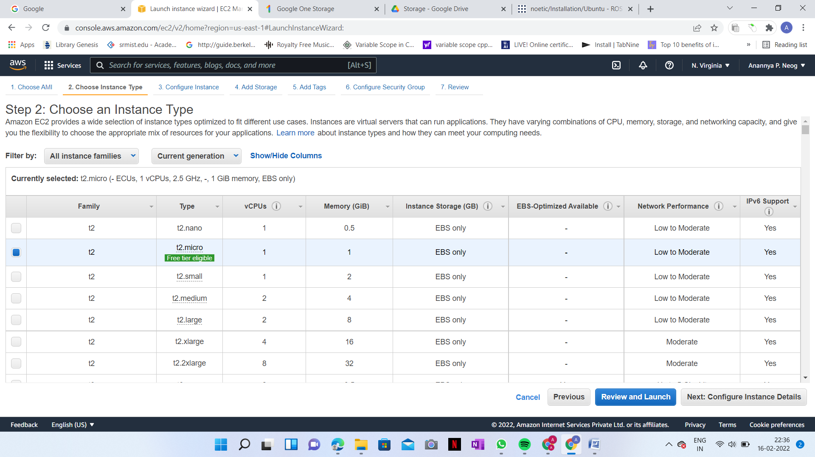

1. **Click ‘Next: Add Storage’**

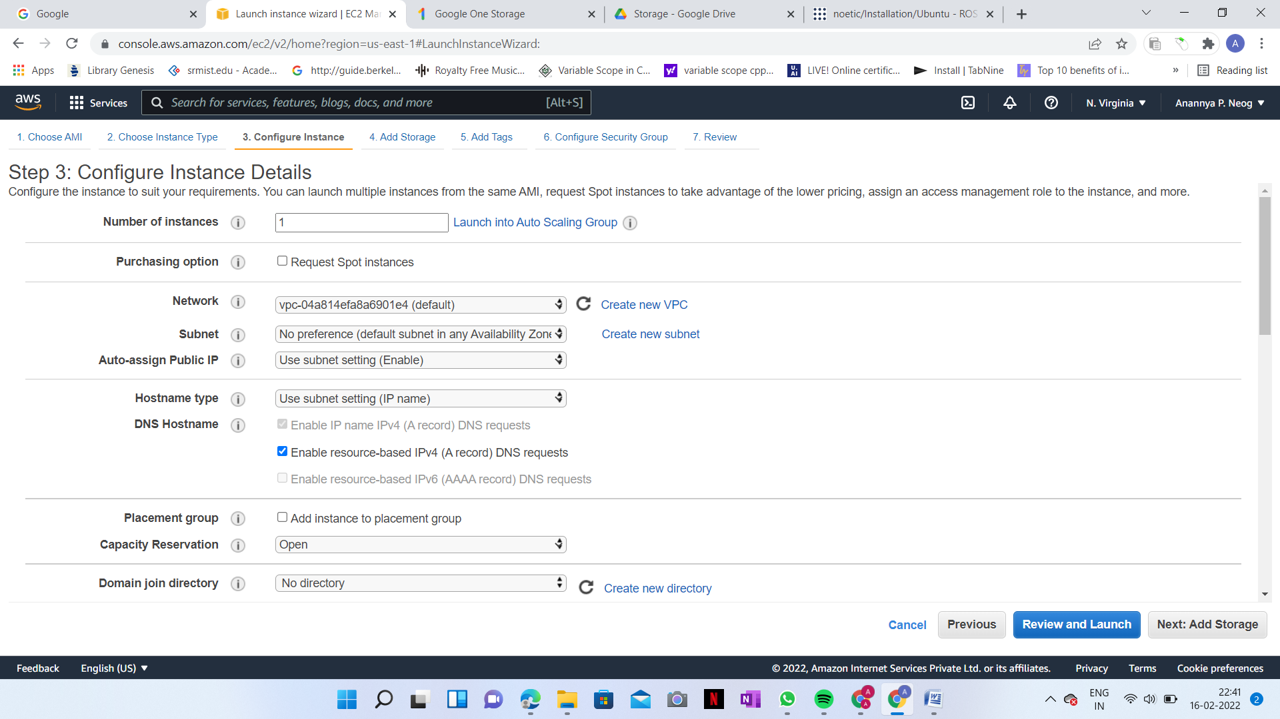

1. **Click ‘Next: Add Tags’**

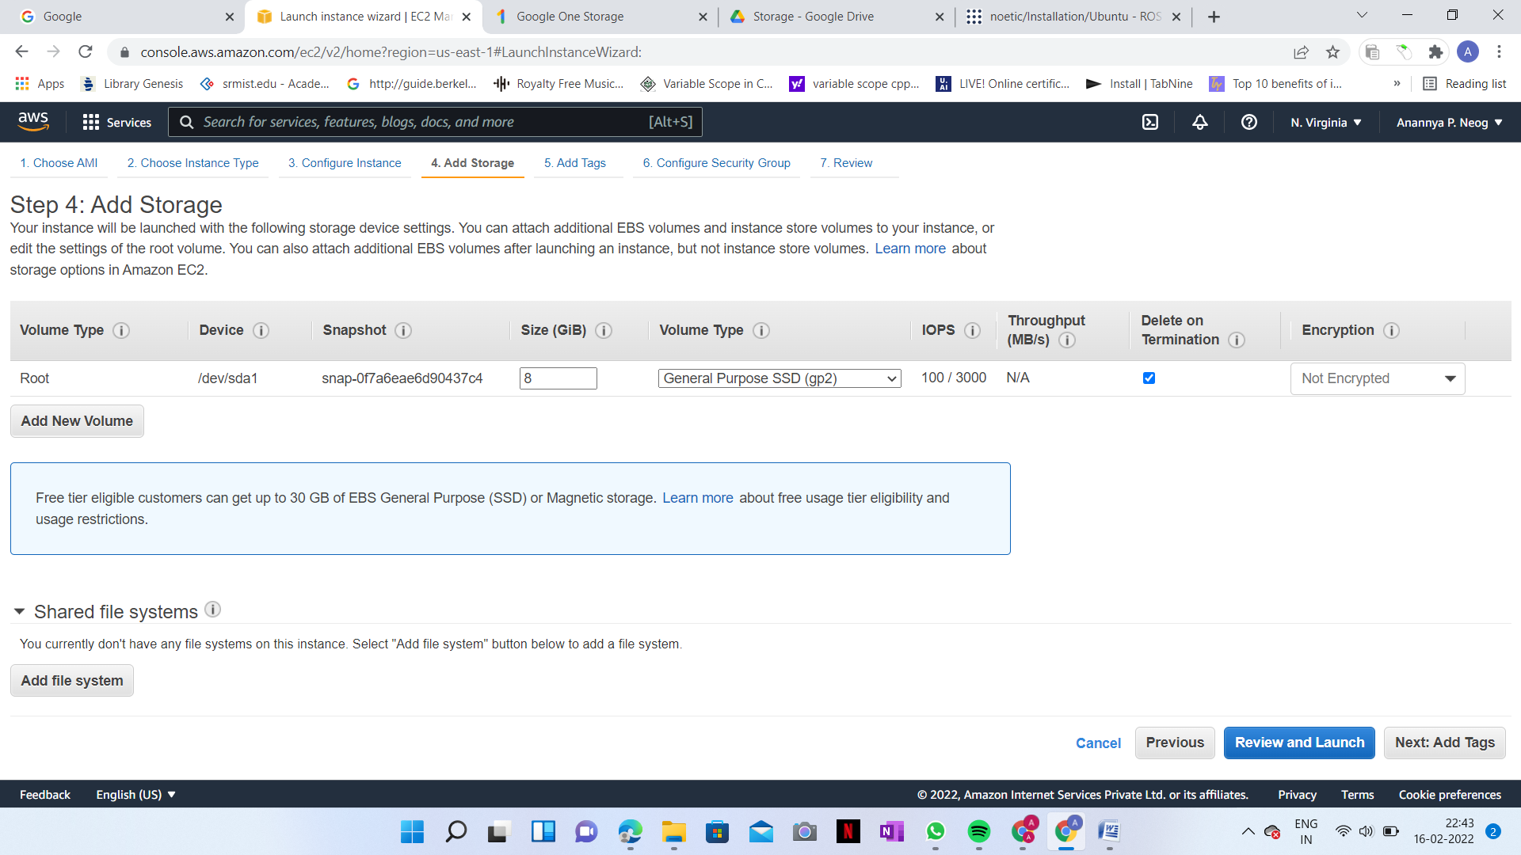

1. **Click ‘Next: Configure Security Group’**

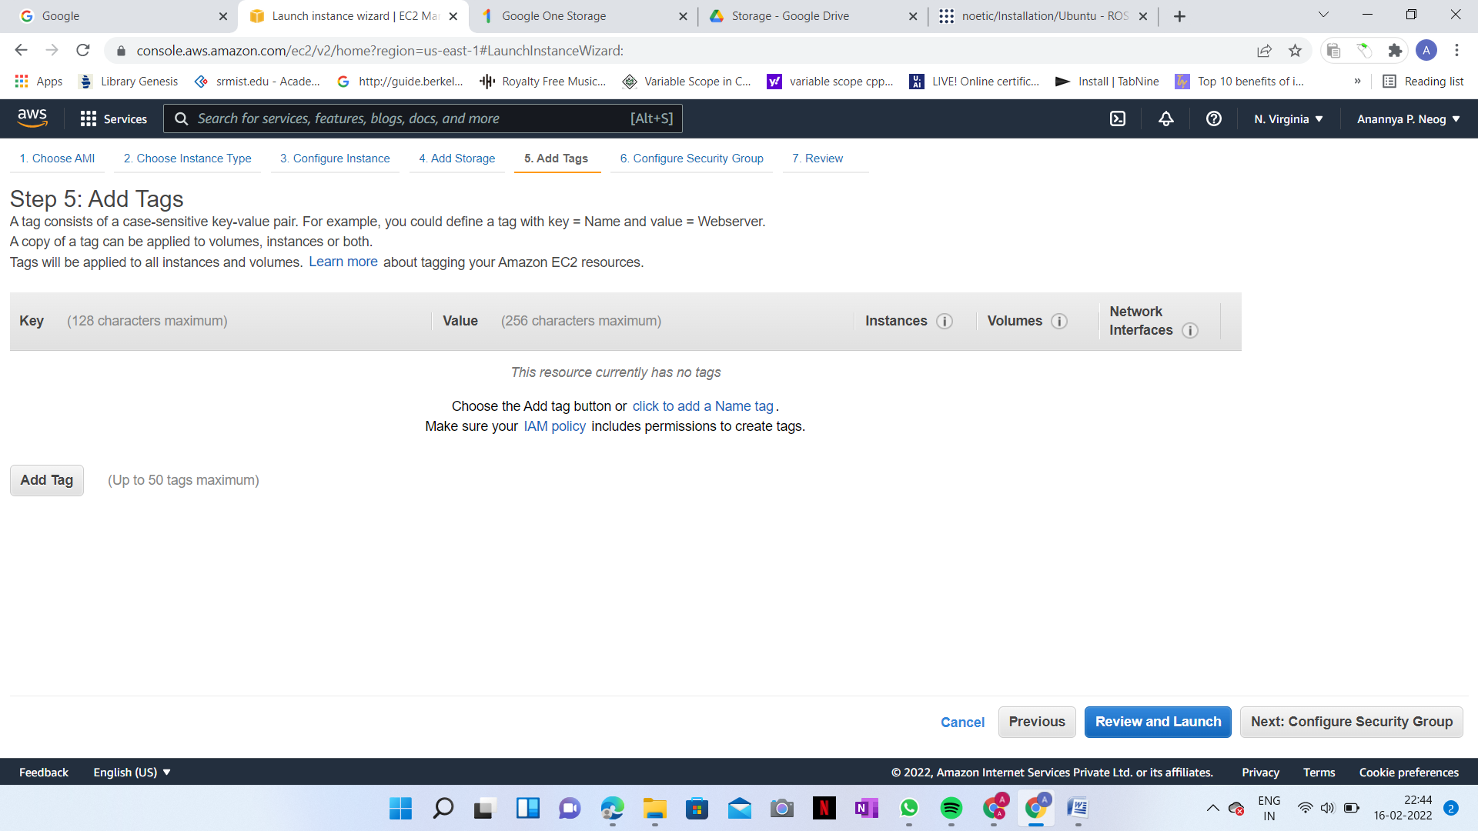

1. **Click ‘Review and Launch’**

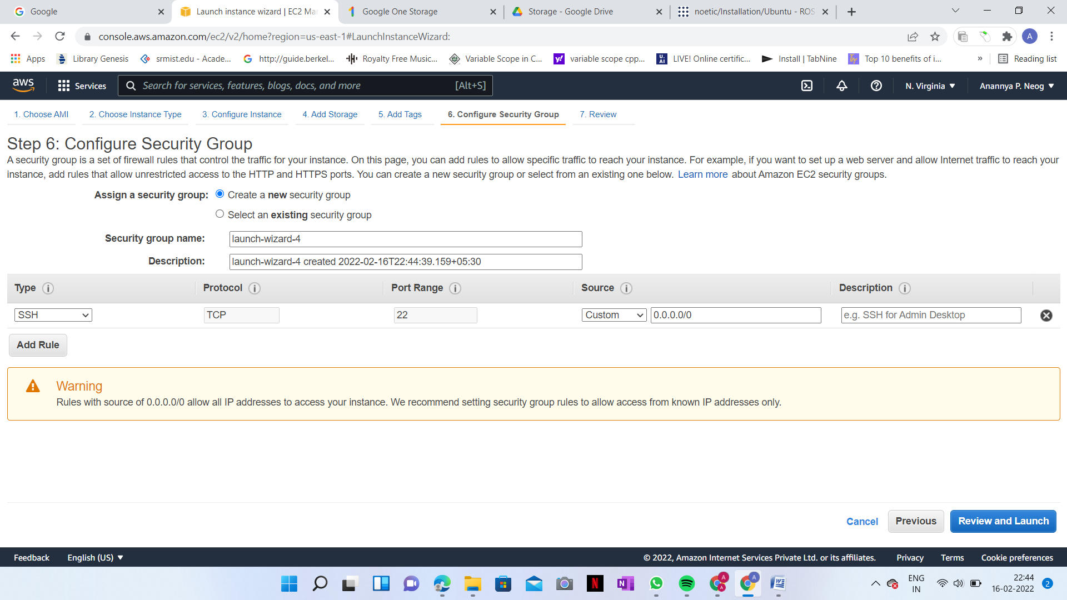

1. **Click ‘Launch’**

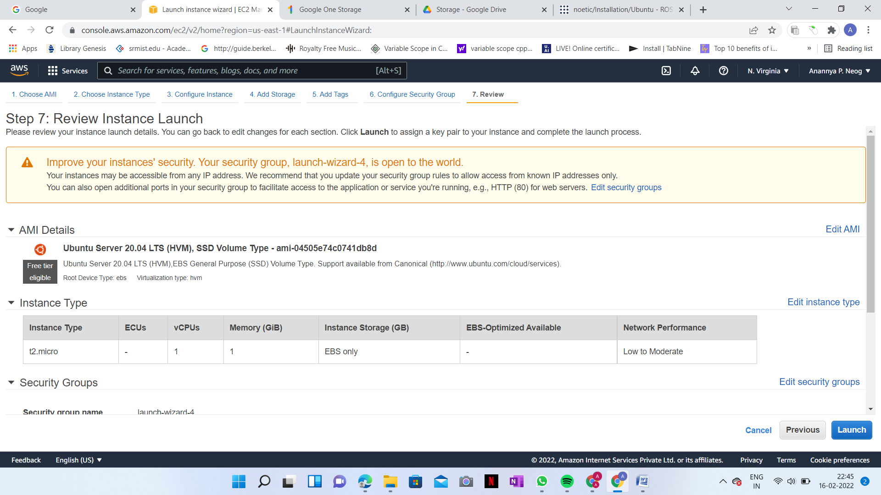

1. **Select any option, mark the tick below and click ‘Launch Instances’**

* We can select any option but I already had so used that one
* Mark the tick button to acknowledge
* Click the ‘**Launch Instances**’ button

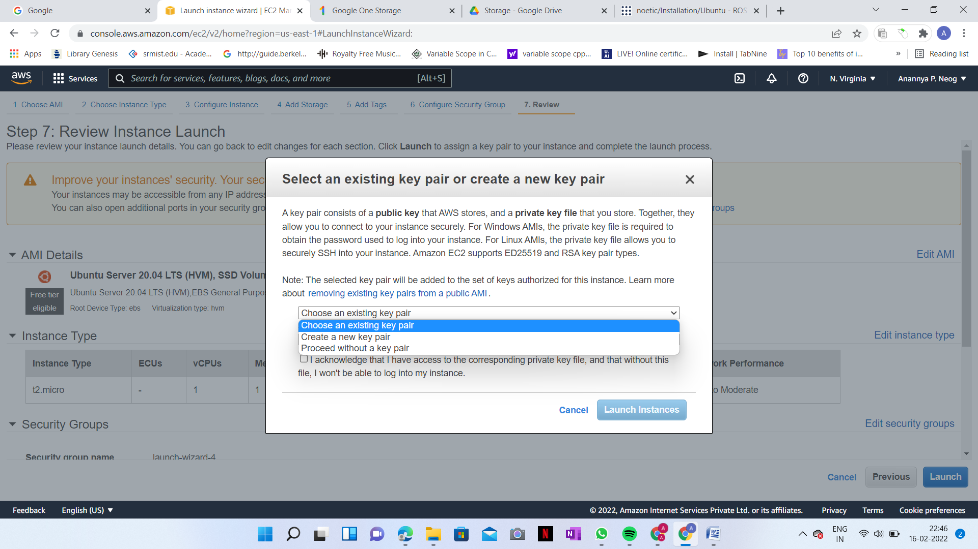

1. **Final Window**

Wait till the instance’s status shows running and then the server is ready

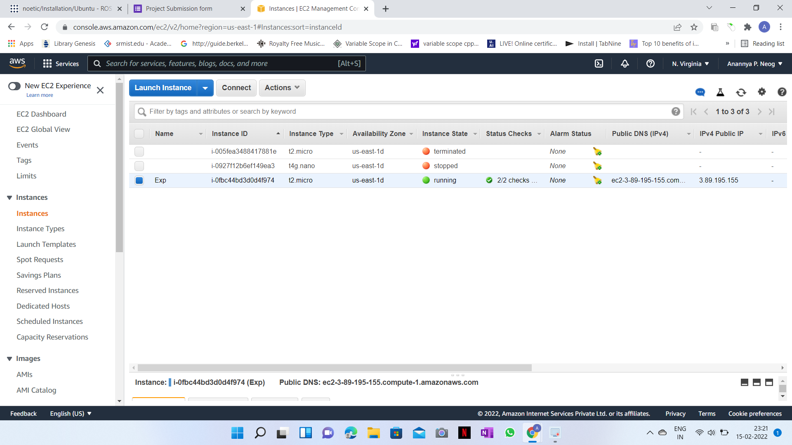

**Steps to Install ROS Neotic (After Cloud is hosted and running):**

1. **Configure your Ubuntu repositories**

Configure your Ubuntu repositories to allow "restricted," "universe," and "multiverse." You can [follow the Ubuntu guide](https://help.ubuntu.com/community/Repositories/Ubuntu) for instructions on doing this.

1. **Setup your sources.list**

Setup your computer to accept software from packages.ros.org.

**sudo sh -c 'echo "deb http://packages.ros.org/ros/ubuntu $(lsb_release -sc) main" > /etc/apt/sources.list.d/ros-latest.list'**

1. **Set up your keys**

* **sudo apt install curl # if you haven't already installed curl**
* **curl -s https://raw.githubusercontent.com/ros/rosdistro/master/ros.asc | sudo apt-key add -**

1. **Installation**

First, make sure your Debian package index is up-to-date:

**sudo apt update**

1. **Desktop-Full Install:**

Everything in **Desktop** plus 2D/3D simulators and 2D/3D perception packages

**sudo apt install ros-noetic-desktop-full**

1. **Slam-Gmapping Install:**

There are even more packages available in ROS. You can always install a specific package directly.

e.g.

**sudo apt install ros-noetic-slam-gmapping**

### Environment setup

You must source this script in every **bash** terminal you use ROS in.

**source /opt/ros/noetic/setup.bash**

**\*NOTE:** To check for more information, visit: <http://wiki.ros.org/noetic/Installation/Ubuntu>

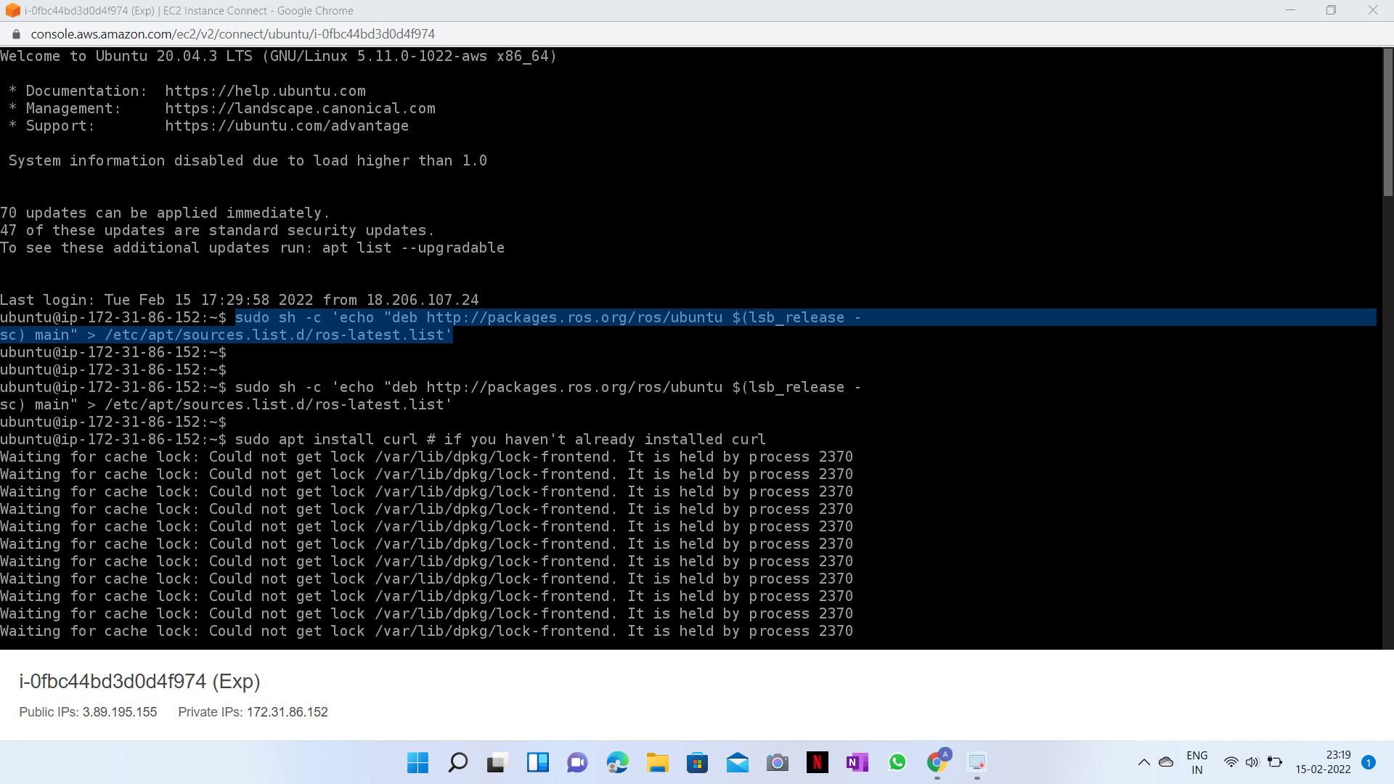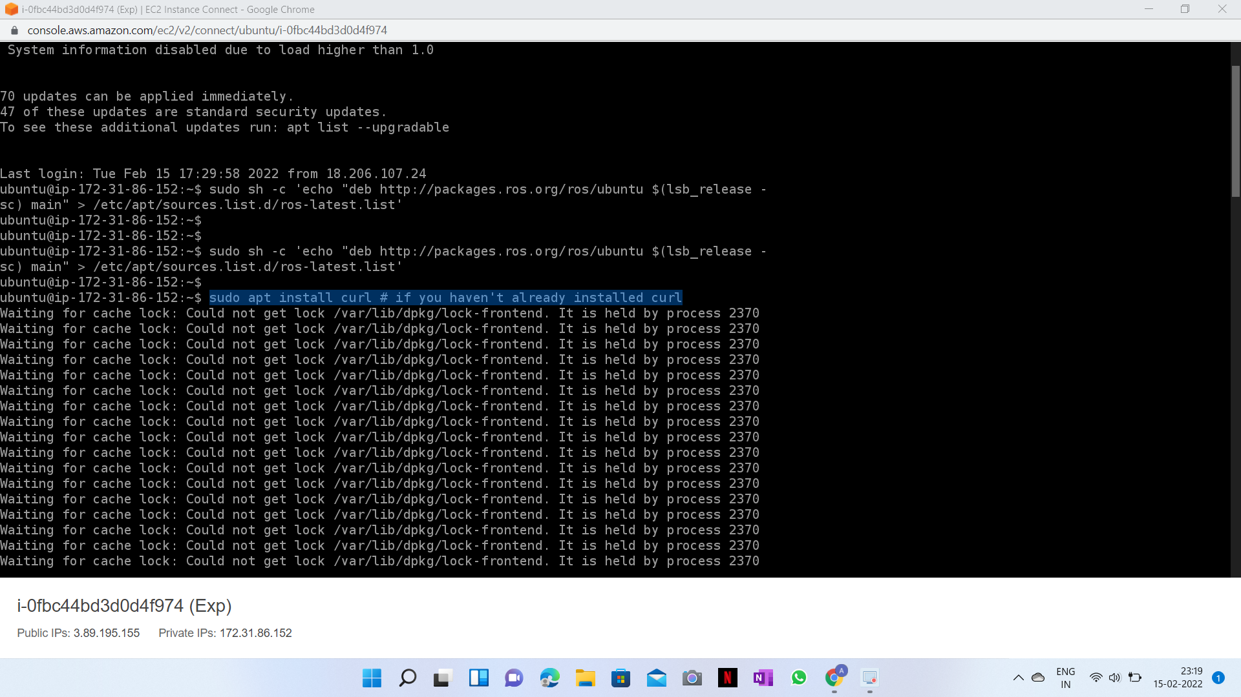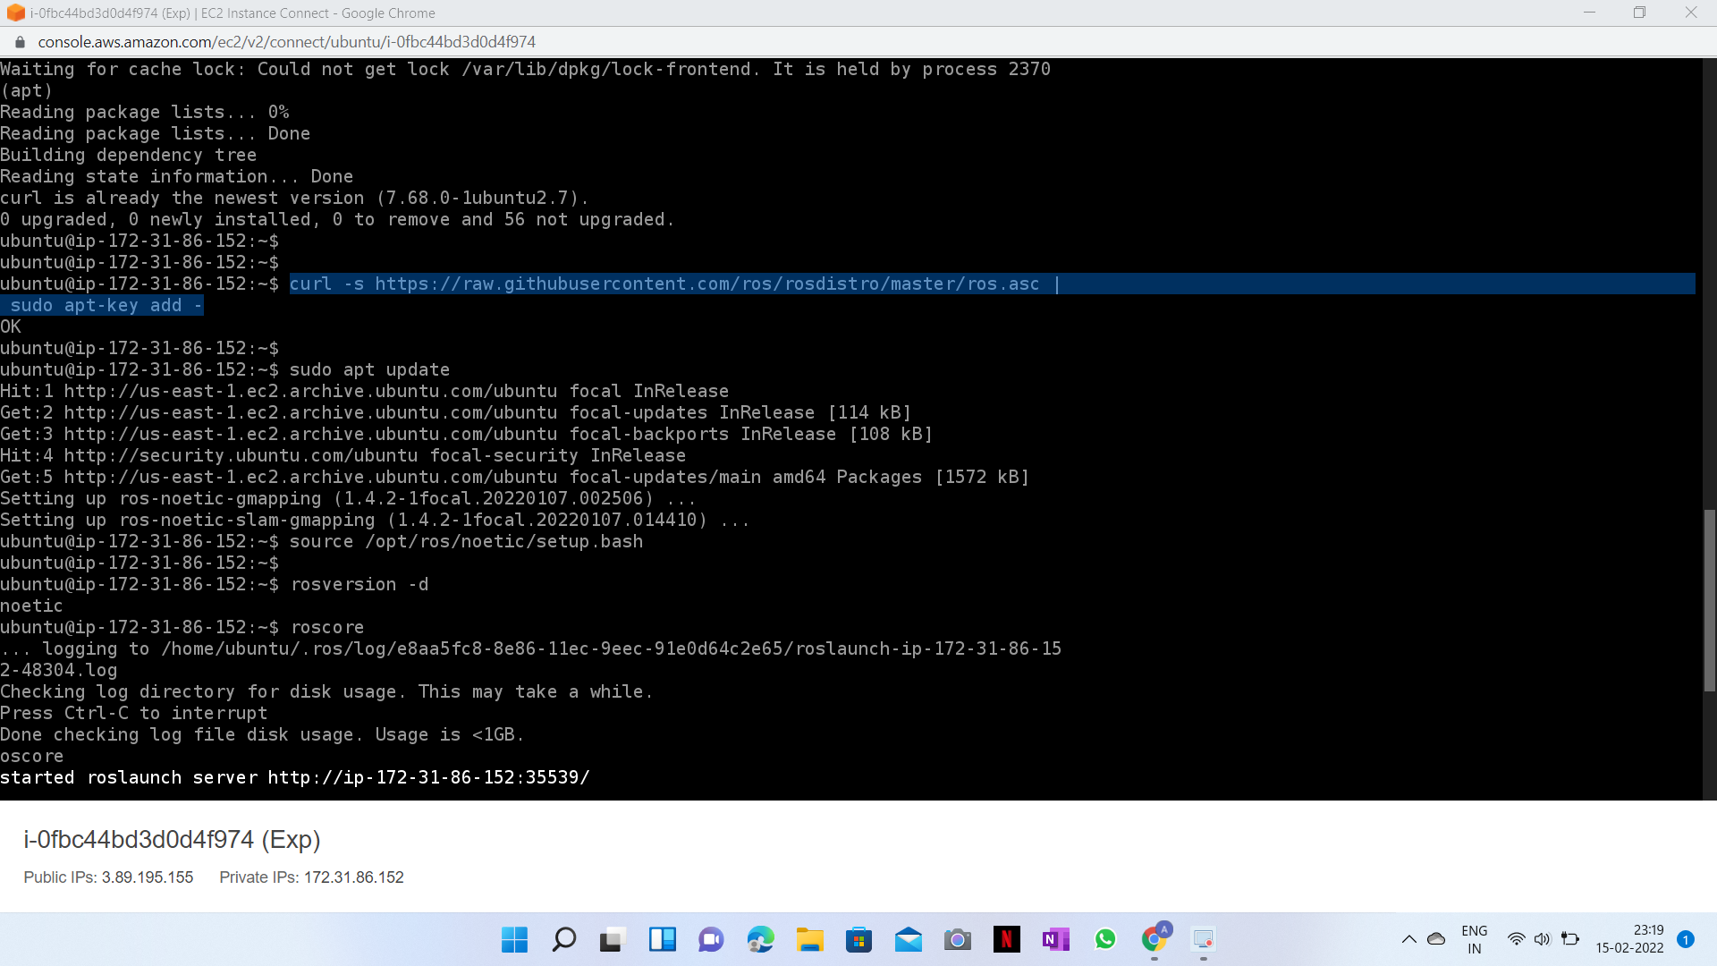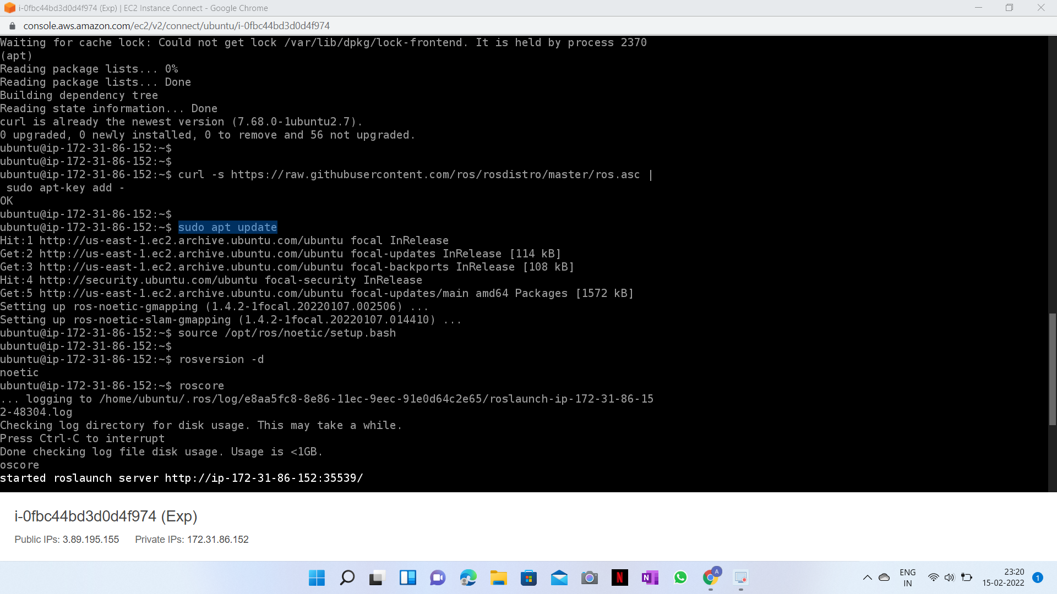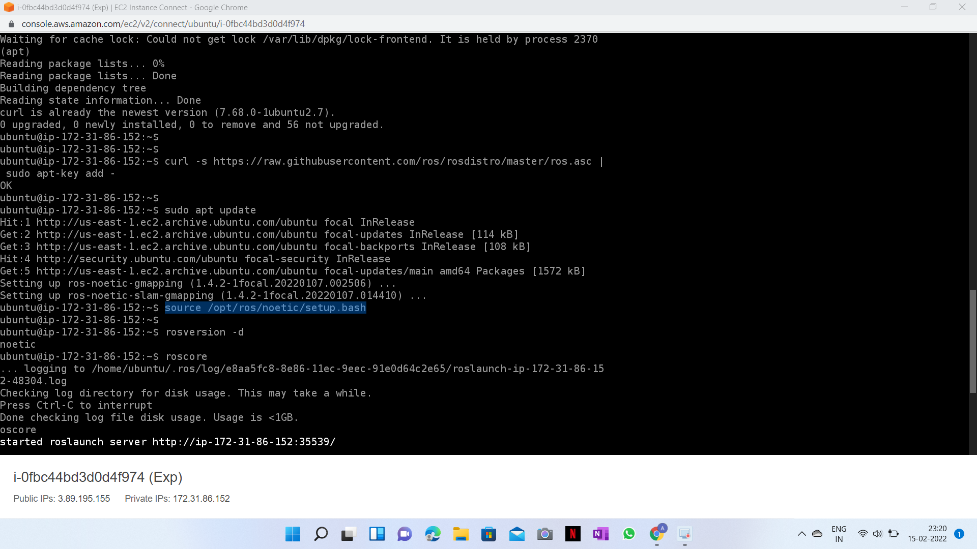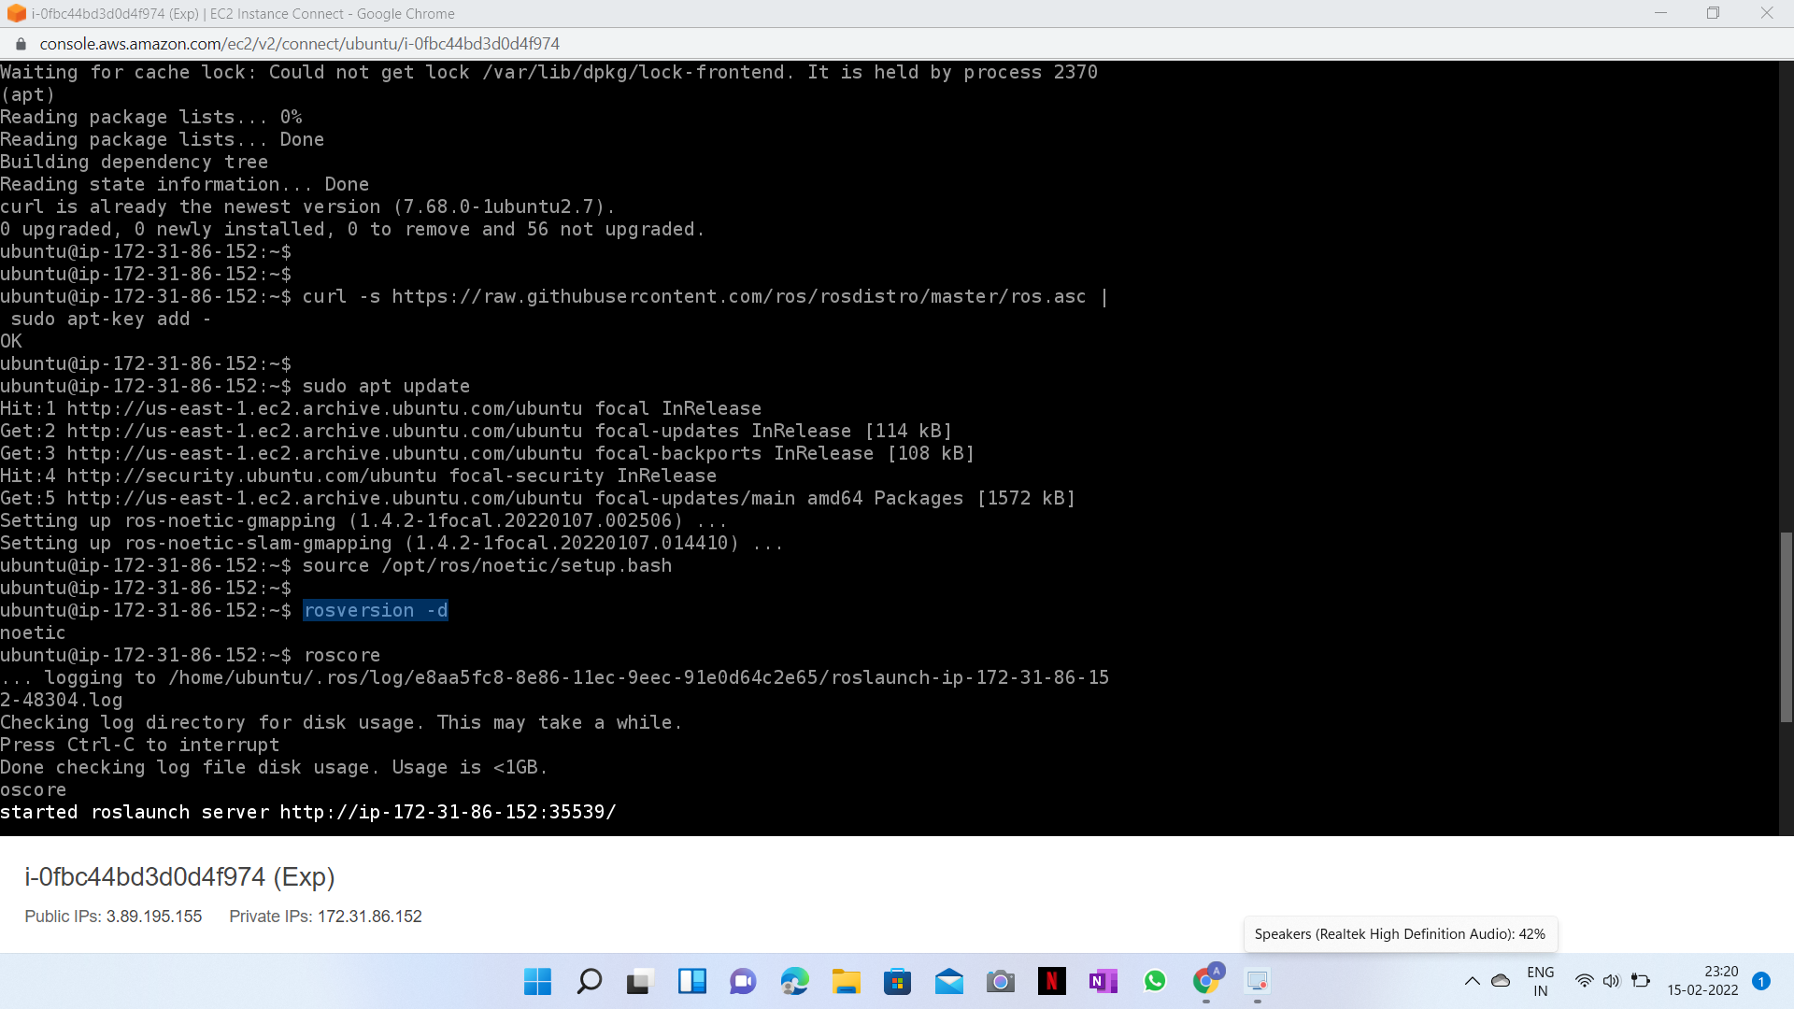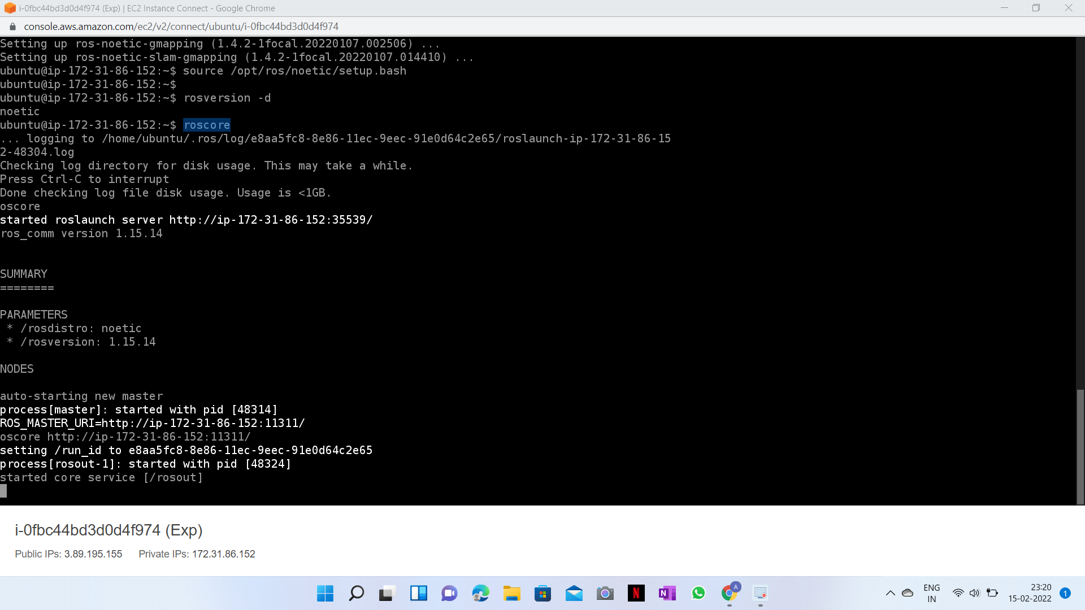

* I’ve also done the same in Ubuntu terminal

